UZDOC 2.0. Consortium meeting no. 5
Budapest, Eotvos Lorand University (ELTE)
12 March 2019 from 14:30 – 18:00

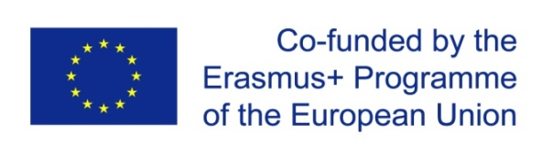 | UZDOC 2.0.: Furthering the quality of doctoral education at Higher Education Institutions in Uzbekistan  573703-EPP-1-2016-1-BE-EPPKA2-CBHE-SP (2016-3796)

Programme as of 05/03/2019

Venue: | Faculty of Education and Psychology, ELTE
Address: | - Budapest, Kazinczy u. 23-27, 1075 Hungary
Reference point: | - ASTORIA Subway

Agenda

1.  2.  3.  4.  5.  6.  7. | PART 1  Welcome remarks were given by the Project Coordinator – Kris DEJONCKHEERE, Secretary General, UNICA, UZDOC 2.0. and the local Project Coordinator, Jasur KARIMKULOV, Vice-Rector for Science, Tashkent Financial Institute, UZDOC 2.0., followed by a Short tour de table. (10’)  Jasur KARIMKULOV Vice-Rector for Science, Tashkent Financial Institute, UZDOC 2.0. & Abdulaziz KURBANOV (KARSU) present the outcome of the 3rd Uzbek Local Coordination meeting in Karshi (3 December 2018) (10’)  WP 2: DEVELOPMENT  - Dilbar ASANOVA presents the Guidelines for the Joint Virtual Doctoral Centre (2.1) (20’)  - Jasur KARIMKULOV (TFI) & Pulatkhon LUTFULLAYEV (NamSU) give a state of play of the purchase of Equipment and functioning of the (virtual) Joint Doctoral Centre (2.2) (10’)  - Zebo BABAKHANOVA (TKTI) will present the JDP proposal in Chemistry (2.5) (20’)  - Antonio Gonzalez (UGR) presents the outcome of the surveys on employers’ expectations from doctorate holders and the level of transferable skills of Uzbek doctoral candidates. (2.8) (20’)  PART 2  WP 4: DISSEMINATION  - Pulatkhon LUTFULLAYEV (NamSU) and Zebo BABAKHANOVA present the translation of the UZDOC 2.0 website (4.3) (10’)  - Gulnoza ARIPOVA (UzSIAC) presents the state of play of the dessimination report (4.6) (20’)  Upcoming activities  Allabay Arziev (QQSU), Jasur KARIMKULOV (TFI) & Bibiane FRECHE & Marie-Noëlle CHAPELLE (2.6) & all project partners discuss Final Consortium meeting, Final Conference & workshop on career development of doctoral candidates - Nukus September 2019  General  Aurelie Duchateau (UNICA) presents the state of play of the general project UZDOC 2.0  Any other business

