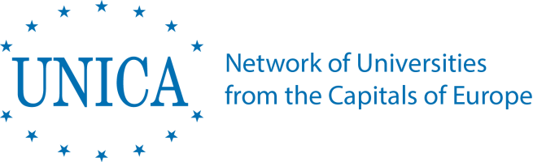

UZDOC 2.0. Consortium meeting no. 4
Tashkent (Tashkent Financial Institute)
Monday, 1 October 2018, 09:30-13:00

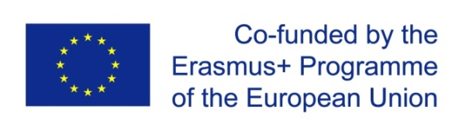 | UZDOC 2.0.: Furthering the quality of doctoral education at Higher Education Institutions in Uzbekistan  573703-EPP-1-2016-1-BE-EPPKA2-CBHE-SP (2016-3796)

Programme as of 30 September 2019

Venue: | Tashkent Financial Institute
Address: | - 60A улица Амира Темура (Amir Temur Street), Tashkent, Uzbekistan
Reference point: | - MINOR Subway station

Agenda

Language of the meetings: English, whispered English to Uzbek translation can be foreseen for colleagues without sufficient command of the English language

09:30-09:45  09:45-10:00  10:00-10:20  10:20-10:40  10:40-11:00  11:00-11:40  11:40-12:20  12:20-12:40  12:40-13:00 | Welcome remarks  - Welcome by the Coordinator – Kris DEJONCKHEERE, Secretary General, UNICA, UZDOC 2.0. Project Coordinator  - Welcome by the Local Coordinator – Jasur KARIMKULOV, Vice-Rector for Science, Tashkent Financial Institute, UZDOC 2.0. Local Coordinator  - Short tour de table  UZDOC 2.0. Midterm report evaluation & general project management – Kris DEJONCKHEERE, Secretary General, UNICA, UZDOC 2.0. Project Coordinator / Aurelie DUCHATEAU, UNICA Project & Communications Officer, UNICA  WP 3: QUALITY ASSURANCE  Presentation of UZDOC 2.0. midterm quality assurance report – Eva OROSZ, Professor, Eötvös Loránd University Budapest  WP3: QUALITY ASSURANCE  Feedback from the external evaluator - Melita KOVAČEVIĆ, Professor at the University of Zagreb, former Vice-Rector for Research & Technology, Vice-President of the PRIDE Network, UZDOC 2.0. External Evaluator  Short coffee break  WP2: DEVELOPMENT  Purchase of Equipment and functioning of the (virtual) Joint Doctoral Centre  Jasur KARIMKULOV (TFI), Ulugbek KHALIKOV (TFI), Pulatkhon LUTFULLAYEV (NamSU)  - Purchase of the equipment: Status report  - Guidelines for the functioning of the Joint Doctoral Centre (deliverables 2.1., 2.2.)  - Planning the first activities of the Joint Doctoral Centre  WP2: DEVELOPMENT  Upcoming activities*  * responsible partners are marked in italics  - Consortium meeting and roundtable with industry and business representatives, Tashkent Financial Institute, 1-2 October 2018 - Jasur KARIMKULOV (TFI), Ulugbek KHALIKOV (TFI), and other partners  - 3rd Uzbek Local Coordination Board meeting at Karshi State  University, December 2018 - date to be confirmed shortly - Jasur KARIMKULOV (TFI), Ulugbek KHALIKOV (TFI), Abdulaziz KURBANOV (KSU)  - Knowledge-sharing event & Consortium meeting at ELTE Budapest, March 2019 – Eva OROSZ, Gabor HALASZ, ELTE Budapest  - Final Consortium meeting, Final Conference & workshop on career development of doctoral candidates - Nukus September 2019 - Allabay Arziev (QQSU), Jasur KARIMKULOV (TFI), Ulugbek KHALIKOV (TFI) & all Project Partners  WP4: DISSEMINATION  Towards the end of the project: Planned dissemination activities & exploitation of project results (discussion)  Next steps and TO Dos

